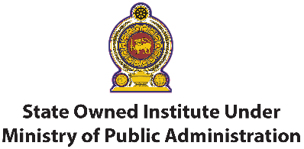

REGISTRATION FORM
Programme Name: Advanced Certificate in Public Procurement & Asset Management

Please fill the following details.

Organization : …………………………………………………………………………………
Address : …………………………………………………………………………………
Telephone : ……………………………..… Fax : ……………..……...………………
No | Name | Designation | Contact No | Email address
01
02
03
04
05

(Photocopy this form for additional bookings.)

Total Amount (Rs. …………………………………………………)
☐ Cash
☐ Cheque no : ………………………………………………………………………..
Bank : ………………………………………………………………………..
(Cheque should be drawn in favour of ‘Distance Learning Centre Ltd.’)
Important: all payment should be made on or before the commencement of the programme.

……………………….… ……………………..….… ……/…..…./…….…
Authorized Signatory Designation or Seal Date

Once completed, please send this form to Email vajira@dlcsrilanka.org or Fax: 011-2552474
For Inquiries 0112-595916 / 071-6588888

