FIBA European mini-basketball convention 2018
Saturday, 2nd – Sunday, 3rd June 2018
Porto/Matosinhos, Portugal

FIBA European mini-basketball convention was held in Porto / Matosinhos in Portugal on 2nd and 3rd June 2018. As the president of Sri Lanka School Basketball Association (SLBSA) and Vice President of Sri Lanka Basketball Federation (SLBF), I was invited to attend the above event by International Basketball Federation (IBF). The purpose of the tour was to present the program of Sri Lanka Basketball Federation to develop Mini-Basketball in Sri Lanka in next five years.
What is Mini-Basketball?
Mini Basketball is a game for boys and girls below 13 years of age. In Sri Lanka, for mini-basketball we focus on age groups of 5 to 13. It is essentially a modification of the adult game, which has been adapted to the needs of children. The aim of Mini-Basketball is to provide opportunities for children of all abilities to enjoy rich experiences that would be transferred to Basketball with enthusiasm. In Mini-Basketball, ball size is reduced to size 4 or 5 and the height of the boards and the basket is lowered. Basketball has many technical rules and in Mini-Basketball these rules are minimized. It is entirely player centered and development focused game.
FIBA European mini basketball convention 2018
The convention gathered 56 representatives from member countries of FIBA Europe into Porto, Portugal for a two-day convention that was held with the aim of promoting mini-basketball game across the Europe. International Basketball Federation (IBF) had decided to invite some member countries from other regions (Oceania, Asia, Africa and America) into European convention to present programs of those countries in promoting mini basketball. The organizing committee had planned the program from 31st May to 5th June 2018. The program is attached herewith. (Annexure 01).
Representation of Sri Lanka
On the invitation by IBF to participate a member from Sri Lanka at the above convention, the Executive Committee of Sri Lanka Basketball Federation (SLBF) decided to hand over the responsibility to me as the vice President of SLBF and the President of SLBSA. Accordingly, I was nominated as the representative form SLBF and IBF accepted my nomination as the representative from Asian region in the above convention.
Participation in the Convention
Having obtained foreign leave from 31st May 2018 to 5th June 2018 I left the country on 31st May at 11.25 a.m. and reached in Lisbon, Portugal at 23.25. Members of National Federation of Portugal had arrived at the airport to receive me and they had arranged my transport from Lisbon to Proto. I arrived at the Tryp Proto Expo hotel at 3.00 a.m. on 1st of June 2018.
01st of June 2018
The program commenced at 10.00 a.m. with a sightseeing program and a boat trip. At 11.00 a.m. a meeting was held at Hotel Crowne Plaza hotel in Proto with FIBA officials, IBF officials and representatives from Oceania, America, Asia and Africa. The President of FIBA international, Officers from Portugal National Federation and IBF officials attended the meeting. Mr. Florian Wanniger, the Director of IBF made a detailed presentation on its vision of promoting mini-basketball across the world and the role of IBF and national federations of each country in this endeavor. I explained the involvement of SLBF and SLSBA in promoting mini-basketball in the country. In Sri Lanka we do not promote competition basketball for kids and conduct only carnivals and jamborees every year in promoting kids game. All representatives presented their involvements in mini-basketball. The meeting lasted nearly two hours and after that all members participated in a lunch hosted by the President of the National Federation of Portugal.
After Lunch, another sightseeing had been arranged to visit a wine cellar, which was a novel experience for the participants. In the evening, all participants visited to watch the semifinal playoff in Portuguese Basketball league. Watching this match gave all members an exciting experience since both teams were extremely superb.

02nd June 2018
The convention formally commenced on 02nd June. In the morning, all participants attended the kids’ events and jamboree. It was an excellent experience for all participants to gain firsthand experience in developing basketball skills of young players. Participants observed workouts and training strategies used by European trainers. All participants had an opportunity to exchange views with experienced trainers from Europe.
After lunch, all participants went to the gymnasium to attend a basketball clinic organized for participants to gain firsthand experience in training skills. Sergio Lara-Bercial, an experienced and renowned sports lecturer and an international basketball trainer conducted the training. It was a great experience for all participants. We observed and participated in the training and had a good perception on training strategies for kids.
After the clinic, an experience sharing session held at the hotel and all delegates, local coaches and international technical officers participated in the event. After the event at the hotel, another on-court clinic was held to display training strategies. After the clinic, delegates again visited the kids’ event at nearby gymnasium.
In the evening a welcome drink and gala dinner was hosted by national federation of Portugal, which gave a very good networking opportunity for all participants.
3rd June 2018
All participants attended the mini-basketball festival that participated 1200 children in the gymnasium. At 10.00 a.m. the conference commenced at the tryp proto hotel. I presented SLSBA’s proposal, a five-year road map to develop mini-basketball in Sri Lanka. The program was well received and appreciated by FIBA and IBF officials. Mr. Florian Wanniger, Director IBF and Mr. Theren bullock interviewed me further on our proposal and assured their fullest cooperation in launching the program. Moreover, based on our proposal they selected Sri Lanka as the center for conducting Asian convention in 2018. IBF promised to bear all expenses amounting nearly 30,000 US$ and equipment including 1000 mini basketballs and requested Sri Lanka School Basketball Association to organize Asian Convention in Sri Lanka with SLBF in December 2018 with the participation of members from all national federations in Asia.
After the wrap up of the program and farewell meeting held in the evening at the hotel Tryp Expo, having completed an extremely successful convention all delegates returned to their countries.
I returned to the BIA at 4.20 pm on 5th June 2018 and reported back to work on 6th June.
No expenses were incurred to Sri Lankan government on my participation at the above event since all expenses on airfare, accommodation, subsistence and incidental were born by FIBA international.

P.A.S.P.Jayalath
Deputy Director of Education
The President SLSBA

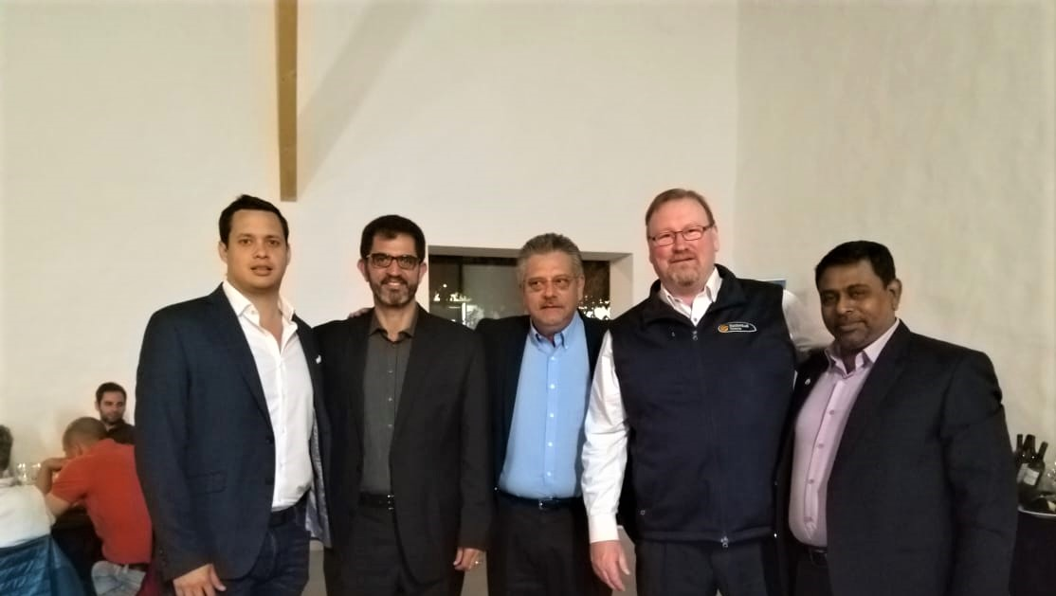
Delegates from countries selected to host 2018 international mini basketball events in Asia- Sri Lanka, Oceania – Australia, America – Mexico & Africa – Egypt,

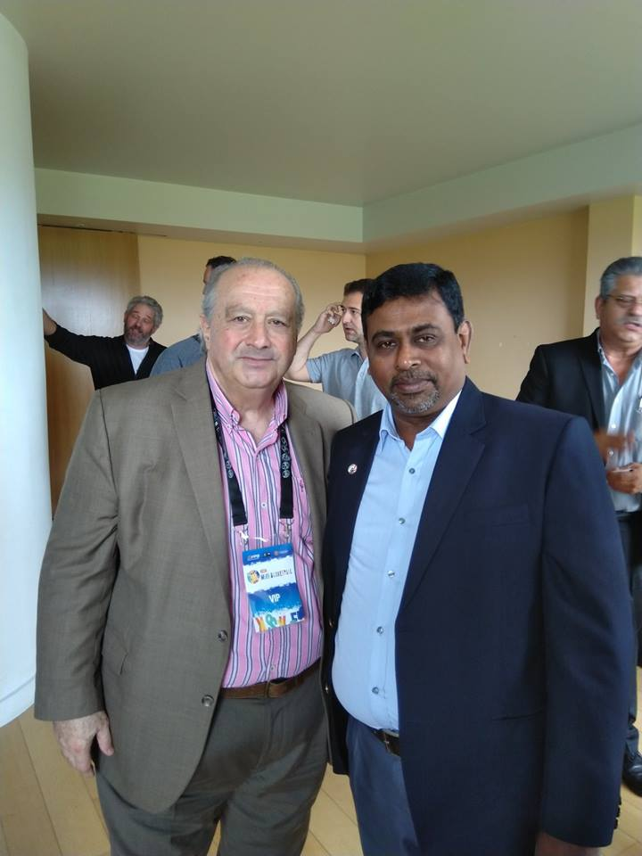

With the president of FIBA international
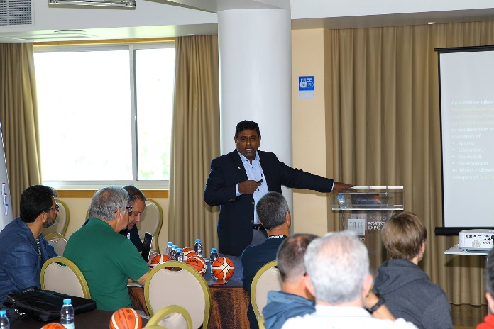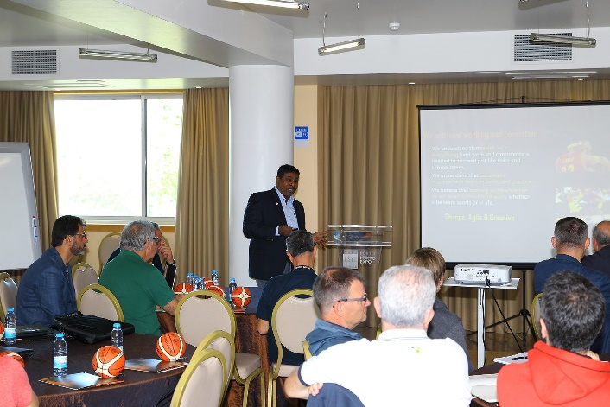

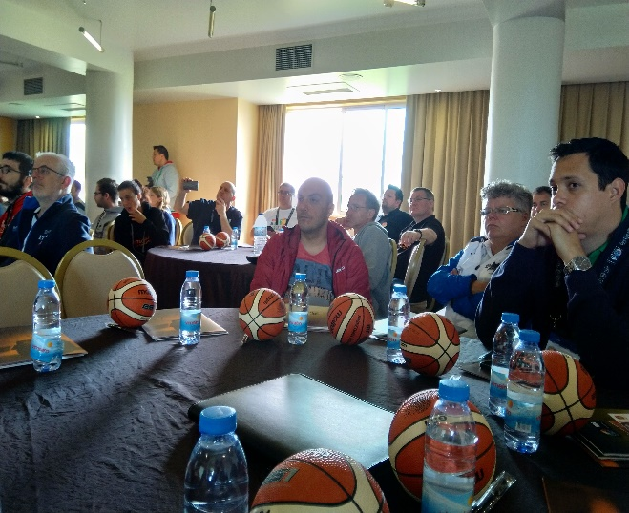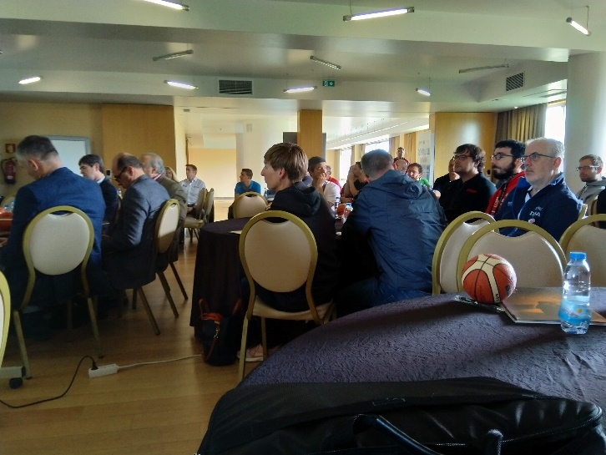
Presenting Sri Lankan Mini-Basketball development plan to FIBA / IBF officials and other international delegates
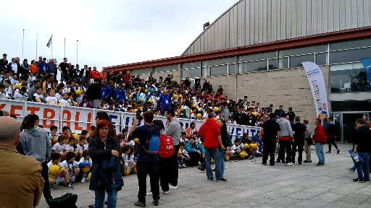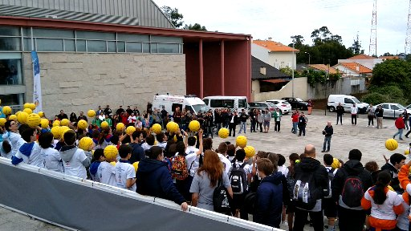
Children’s event – European mini basketball Jamboree

