Le Stage Didactique à l’institut de Touraine, Tours, France (2019/07/01-2019/07/31)

Teacher Training Programme for Teaching French as a Foreign Language at the Institute of Touraine, Tours, France
(2019/07/01-2019/07/31)

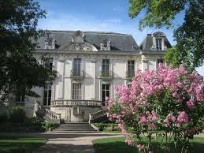

Reported submitted by Ruwandini Ranatunga
Mahinda Rajapaksha College, Homagama.

As a foreign language, the Institut de Touraine has been offering, every summer for many years,vocational training courses. The training program encompasses all teaching skills including teaching “phonétique “, reading, listening, speech and grammar. The French Language Teachers’ Association in Sri Lanka, together with the Embassy of France, Sri Lanka, offers a scholarship opportunity for a French teacher in Sri Lanka, to attend the aforesaid programme. Le Satge Didactique program is held annually in the Institut de Tourraine, France, with the aim of developing teaching competencies of teachers teaching French as a foreign language, anxious to be as close as possible to the expectations of teachers and future teachers of French.
In 2019, I got that opportunity and it contributed a lot to improve my teaching skills in the all related domains. The four week teacher training program catered to all teaching domains including teaching speech and phonetics, teaching writing and grammar,teaching listening and reading.
The training staff at the Institut de Touraine has adopted a thematic approach: each week, a new theme was addressed, presented with linguistic and phonetic modules as well as with conferences and workshops. Each day gave rise to a combination of courses, workshops, exchanges of practice and analysis on concrete issues which were supposed to motivate the audience, manage heterogeneity, develop interaction and creativity, in particular through teaching the five senses, build confidence in itself in the learner.
General objectives of the training course were as follows
- Diversify class practices,
- Deepen their practical knowledge in a thematic context,
- Create educational material,
- Access many suggestions for activities in all skills,
- Develop and perfect linguistic and phonetic skills, of the teachers
- Exchange with other teachers from various countries on shared issues:
- motivation of learners, use of ICT, integration of phonetics in class, etc.

The following discussion questions regarding the teaching learning process were taken into consideration. I personally believe that these questions address to many teaching issues faced by the Sri Lankan French language teachers.

- How to motivate my learners?
- How to be more creative in my lessons, how
- adopt a differentiated pedagogy?
- Why ? In what way?
- My manual is not
adapted, how to do?

New Ideas

The following new ideas could be formulated after attending the four week training program.

◦ Possibility of using innovative practices and classroom simulations
◦ Possibility of exchange of classroom practices
◦ Possibility of using concrete and innovative proposals for teaching material
◦ Possibility of using joint development of sequences (with the other French teachers of the same school and maintaining a bank of activities
◦ Possibility of using initiation or didactic deepening
◦ Possibility of using differentiated pedagogy
Linguistic and phonetic deepening and reinforcement
3 weekly sessions in language class and / or in a language laboratory with
an experienced teacher in order to:
◦ see or review certain points of language, correct any fossilized errors,
◦ develop grammatical, syntactic and lexical knowledge,
◦ work on pronunciation, improve prosody, intonation,
◦ extend their teaching skills through observation and use as
learning the techniques and materials used
Doing interactive group activities for cultural exposure

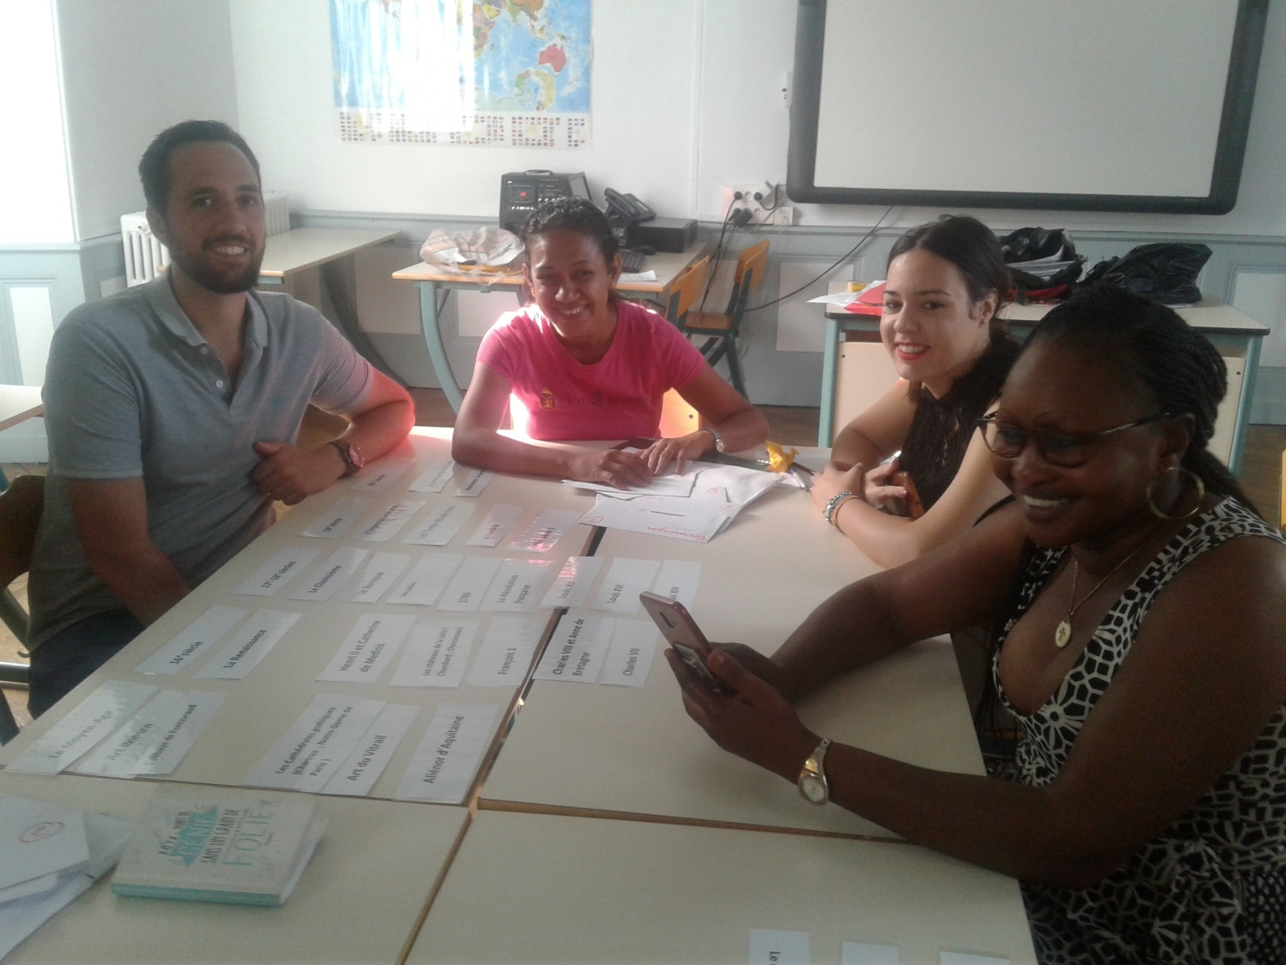

Encouraging students’ French speech through singing

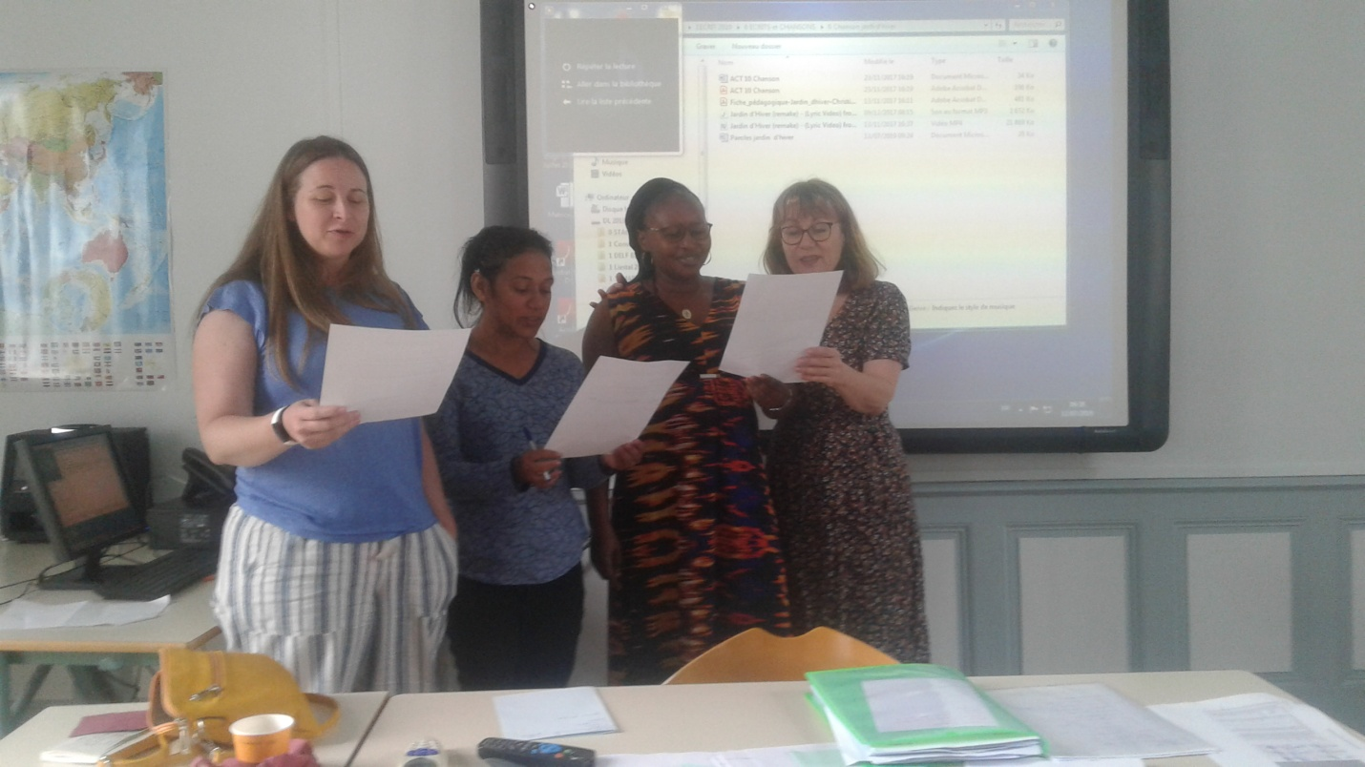

Sharing teaching strategies with international teacher community

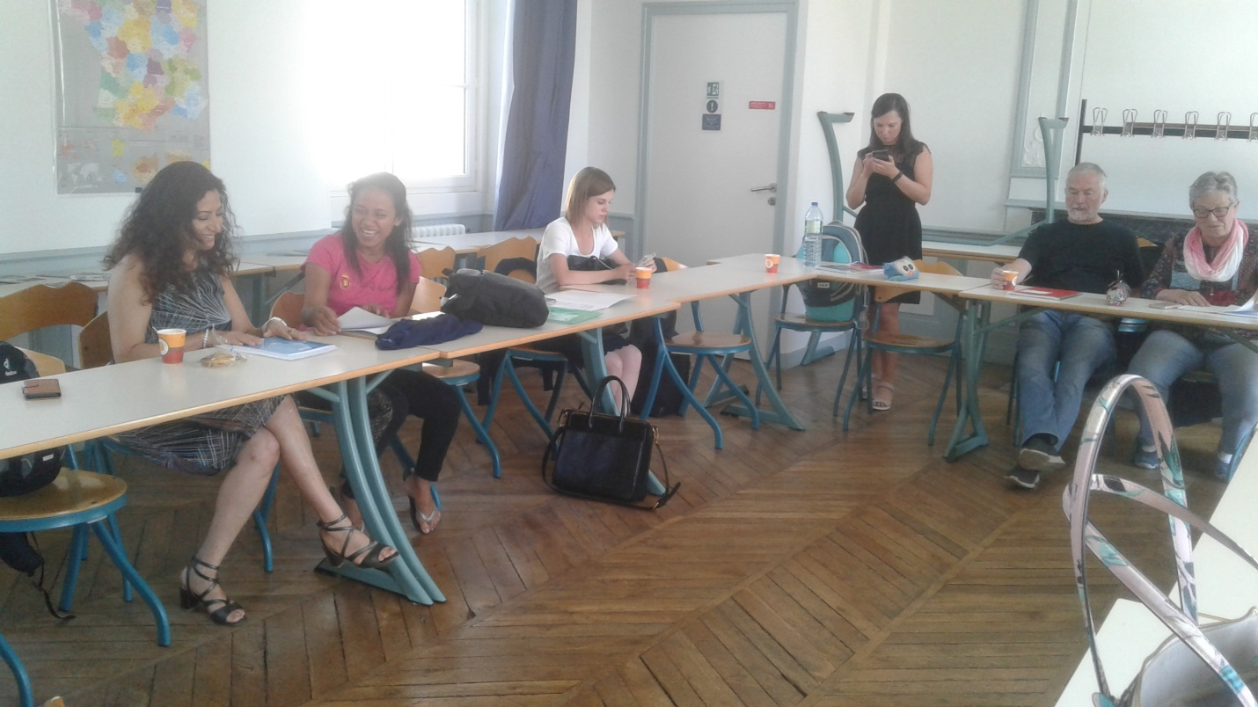

Proposals adaptable to the local situation
1.After the training I understood that one of the most important projects regarding teaching French as a Foreign Language is to arrange opportunities for cultural exposure regarding language. Though not evaluated at the examinations, it is highly important for the students to accustom themselves both to the linguistically and culturally established practices of the target language. Though it is true that a number of leading schools already do have language day programs to encourage the students’ cultural familiarity, I propose that those programs should be held at ministry based level encouraging competition among schools.

2. Speech Tests
At present speech is not tested in French as a foreign language classes. However, since speech is an integral part of any language, I strongly propose to introduce a speech component at least for school based term test evaluations.

3. Listening Activities
Similar to speech, listening too is a skill that goes untested at present in Sri Lankan French education. However, listening and understanding the content is essential even for basic practical use of language, Therefore, I suggest introducing listening activities and especially those that are based on cloze activities focused on songs and dialogues. Internet offers a plethora of activities for this purpose.

