Report on International Seminar on Developing Support System for Rural Teachers for ASEAN Countries
6.11.2077 – 13.11.2017
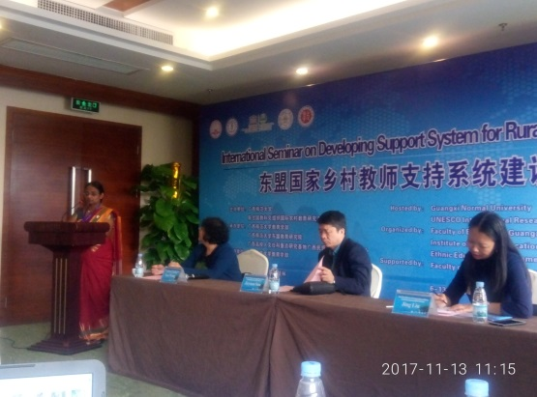
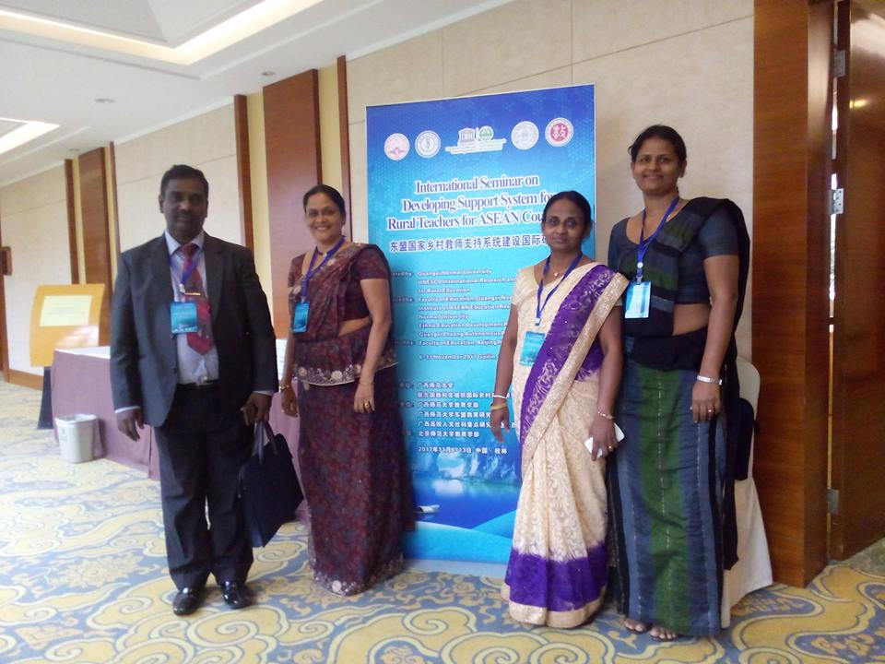
Guilin, China

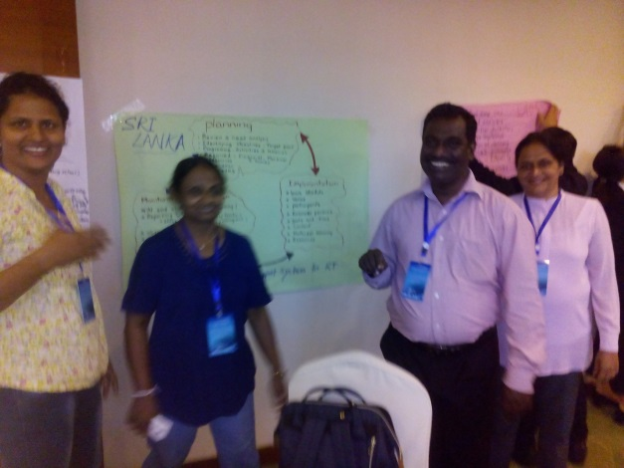

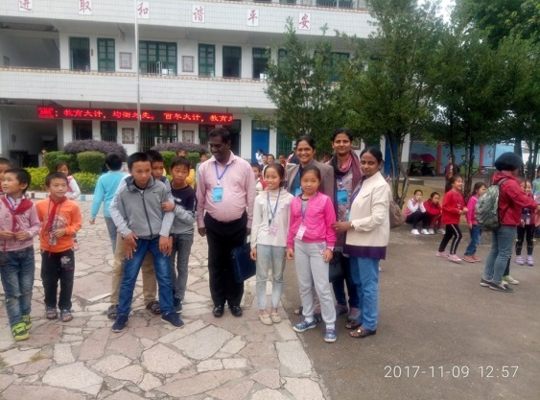

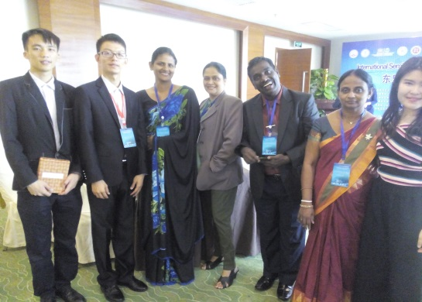

Mrs. B.G. I. Kalani Hemalie – Deputy Director (SLEAS)
Mrs. Ridma Bulathsinghala- Assistant Secretary (SLAS)
Mrs. S.T.R. Herath- President, Mahaweli National College of Education (SLTES)
Mr. S.A.Priyantha- Vice President, Siyane National College of Education(SLTES)

Report on International Seminar on Developing Support System for Rural Teachers for ASEAN Countries

Introduction
UNESCO International Research and Training centre for Rural Education (INRULED) and Guangxi Normal University of China jointly hosted an International Seminar on Developing Support System for Rural Teachers in Guilin from 6 – 13 November 2017 & sponsored by Guangxi Normal University.
The seminar was held over 8 days & it included thematic workshops, country presentations, field visits & discussions on policies & practices about Rural teachers' Continuous Professional Development with the participation of ASEAN countries (The Socialist Republic of Vietnam, Philippines, Malaysia, Indonesia, Thailand Myanmar, Lao Peoples is Democratic Republic) & Sri Lanka.
Overall goal of the seminar was to enhance the capacity of key stake holders, including government officials and education practitioners to effectively integrate the concept of support system for rural teachers’ professional development & it aimed to,
- Share good practices regarding priorities & strategies to promote rural teachers’ professional & social status, improve rural education quality through motivating & supporting teachers.
- Build a common understanding of support system for rural teachers’ continuing professional development(CPD) among the participants from different countries & contexts.
- Provide space for diverse range of stake holders to voice their thoughts, analysis & aspiration for rural teacher support & development, which would form a foundation for further research & cooperation
- Build up a network for policy dialogue about Rural teachers CPD and information sharing among participating countries
- Identify the learning needs in terms of capacity building for both trainers & trainees in the area of rural teacher education, teacher support & development.
It was a great opportunity to engage in dialogue about key issues in teacher policy and practices, including teacher preparation, recruitment, retaining teachers for rural school teachers’ CPD, teachers’ status, working conditions, the challenges and the gaps in implementation.

Observations:
- Chinese government pays more attention on rural teacher development & their professional development & already they have sound mechanism for teacher development.
- They have following types of teacher education programmes for rural teachers.
- Short term teacher training programmes
- Long term (3 to 6 months) programmes
- Teacher development work shops (According to their subjects)
- Workshops on sharing experience.
- Teacher exchange programmes from urban to rural schools
- Internship in urban schools for rural teachers to learn through observations, discussions, demonstrations and feedbacks.
- 46 hours of compulsory CPD for rural teachers as policy requirements

- Chinese school system is different from Sri Lankan school system & most of high schools have been affiliated with universities. Those schools are known as "University Colleges". Unlike in Sri Lanka kindergarten also is also included to the government education system.
- University education faculties, teacher training colleges directly give support to develop rural teachers attached to their university colleges and most of high schools have organized many teacher development programmes for rural teachers.
- Chinese government & institutions pay more attention on education researches & policy making is highly based on research findings in regarding to the education. Therefore adoptability & sustainability is very high when introducing new systems, policies, etc...
- In China, they have used “we chat” application & introduced a successful teacher education program through mobile phones in addition to E learning opportunities through onsite and online learning.

Suggestions to improve rural teacher education
- Develop CPD policy and a system,
- that meets local needs & creates local solutions. E.g. school based support systems & school cluster system
- that include local leadership to be able to plan short, medium & long term plans
- that consider both institutional & individual CPD needs
- using bottom up CPD strategies & reflective models of CPD
- using experience teachers within the community as coaches & mentors
- with an effective monitoring and evaluating mechanism based on research basis

- Pay more attention on rural teacher development to retain quality teachers in rural areas. ( difficult & very difficult schools)
  - Provide incentives to attract more experienced & new teachers for rural schools
  - Use peer support systems, collaboration with other teachers & schools, network beyond the school community e.g.; other institutions, external links
  - Provide systems that offer continuous support; collaboration with National Colleges of Education (NCOEs) & teacher centers
  - Introduce honor system for teachers who works more years in rural schools
  - Introduce & maintain proper transfer system
E.g. rural teachers can transfer after compulsory 3 years of works, etc…

- Develop system to improve the quality of rural teachers
- Develop learning communities; use of distance learning education & ICT systems
- Provide relevant resources to NCOEs and teacher centers such as internet & WI-FI facilities
- Develop systems that offer continuous support for rural teacher training in collaboration with National Colleges of Education (NCOEs) and teacher centers.
- Acknowledge teacher’s prior experiences, knowledge and dedication eg. Incentive schemes, etc…
- Develop school cluster systems

- Strengthen the National Colleges of Education & Teacher Centers in regarding rural teachers’ continuing professional development
- Provide necessary physical & human resources e.g. internet, Wi-Fi, etc…
- Conduct workshops for teacher educators to emphasize the importance of CPD, in-service teacher trainings specially relevant for rural teacher education
- Introduce continuous teacher supportive systems through NCOEs
- Let NCOEs take the lead to teacher supportive systems
- Introduce incentive/appreciation system for teacher educators regarding their contribution to CPD of rural teacher education

- Develop mechanism to emphasize the importance of researches in rural education sector & use of research findings to make new rural education policies.

- Introduce induction training ( at least 3 months) for newly recruited graduate teachers including teaching methods, teaching materials, teaching environment, etc…, since they have no prior experience of teaching.

- Develop a degree programme in universities with joint collaboration of Ministry of Higher Education to make teaching more professional occupation.
e.g. B.A./ B Sc. (teaching)

- Involve partners & community to raise awareness of the importance & relevance of education to bridge socio economic disparities

“It is widely recognized that quality teachers are a fundamental condition to the success of any efforts to improve the quality of education”

