ASIA-PACIFIC MINISTERIAL FORUM ON ICT IN EDUCATION (AMFIE) 2017
Background
On 25 September 2015, the 70th UN General Assembly formally adopted 17 Sustainable Development Goals (SDGs) that will frame policies and programmes of Member States over the next 15 years. The SDG4reaffirms education as a fundamental human right and a key catalyst for achieving wider development goals. It aims to “ensure inclusive and equitable quality education and promote life-long learning opportunities for all”1 through an integrated approach. This echoes the collective commitment of the international education community with the Education 2030 agenda, which was set out during the World Education Forum (WEF) held in Incheon, Republic of Korea in May 2015. The core premise of Education 2030 is to ensure comprehensive renewal of the education sector to build a lifelong learning society, targeting its development across all levels and areas, all the way from early childhood care and education to K-12 to vocational and tertiary education.
Notably, Education 2030 and its associated Framework for Action2 recognizes the immense potential of ICT in attaining the lifelong learning goal for all. It highlights the need for ICTs to “be harnessed to strengthen education systems, knowledge dissemination, information access, quality and effective learning, and more effective service provision”. As an immediate follow-up to WEF, the International Conference on ICT and Post-2015 Education Agenda, was held in Qingdao, PR China in May 2015. The forum discussed proactive sector-wide strategies to leverage the power of ICT to transform education, as well as to establish targets and benchmarks to coordinate global partnerships. The ensuing Qingdao Declaration3 underscores the potential of relevant ICT-based resources and solutions in providing access to lifelong learning opportunities, enhancing the quality of learning, supporting teacher innovations and knowledge-sharing, diversifying learning pathways and modalities, and enhancing the management of education systems.
UNESCO Bangkok takes advantage of this momentum by bringing together education policy makers in the region to the Asia Pacific Ministerial Forum on ICT in Education (AMFIE) 2017 to revisit and refine the role of technologies for the Asia-Pacific Member States in achieving the Education 2030 agenda. Specifically, it aims to reach a high-level agreement on a regional strategy to unleash the potential of ICT to facilitate the achievement of SDG4.
Forum Objectives
1) Create opportunities to share policies, challenges, experiences, and innovations across countries in the Asia-Pacific region and beyond;
2) Deliberate on the Regional Strategy and explore country-level support towards providing ICT- supported education opportunities and services that value inclusion, innovation, and empowerment, specifically by:
a. Identifying how ICTs can address issues related to access, diverse needs, lifelong learning, etc.;
b. Facilitating educational innovation and transformation through ICT;
c. Fostering a favourable ICT-supported learning environment to empower citizens; and
3) Promote bilateral and multi-lateral collaborations and other forms of partnerships within the region towards the efficient and effective use of ICT in education
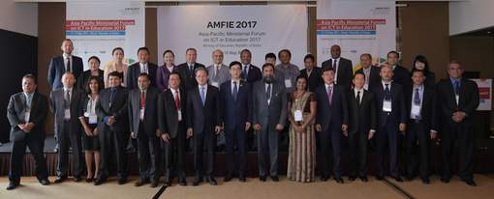
Venue: Garnd Hyatt Hotel, Seoul, South Korea
Dates: 11th – 12th May 2017

Day 1: Thursday 11th May 2017
Delegates from 30 member states registered for the 2 days forum and welcomed by H.E. Joonsik Lee, Deputy Prime Minister and Minister of Education, Republic of Korea. The forum opening remarks were done by Mr. Gwang-Jo Kim, Director, UNESCO Bangkok; followed by the welcome address from the Mr. Seog-Soo Han, President Korea Educational Research Information Service (KERIS). The key note presentation was done by Mr. Paul Kim from Stanford University, USA. Mr. Kim’s presentation was on how to leverage ICT to achieve a lifelong learning society.
In the afternoon session there were 3 speakers. Mr. Gwang – Jo Kim, Director UNESCO, Bangkok on Education Agenda 2030 and ICT. In his presentation he discuss SDG and ICT, status of ICT in Asia Pacific region. Mr. Wei Loong David Hung of National Institute of Education, Singapore presented on Evidence‐Based Policy and Practice in ICT‐Transformative Education with Singapore experiences in Schools and model for the system change. Mr. Brajesh Panath, Technical Advisor for Education, ADB presented on Fostering Smart Partnership which described key challenges and opportunities to Education, why partnership critical and way forward ideas.
In the evening Ministerial Dialogue has begun. Ms. Jonghwi Park described the overview of Asia Pacific regional strategy which was already distributed among member states including the analysis of survey reports obtained from the member states. The regional strategy was introduced by Director, UNESCO Bangkok and Ministers and heads of Delegation of member states proposed the amendments and the amended strategy was approved.
Five sub regions of the Asia Pacific Region namely South& West Asia, Central Asia, Southeast Asia, Pacific,East Asia had separate discussion and agreed on three priority areas to implement the said strategy and build up action plan. South& West Asian sub region is comprised of Sri Lanka, India, Pakistan, Bangladesh, Bhutan and Afghanistan (participated states only). Sri Lanka, Pakistan and India emphasized the importance of educational content in the field of ICT in Education. Pakistan proposed to include educational e- content development as a new concern area. Therefore South & West Asian sub region presented Quality of Teaching and Teaching Practices, inclusion & Equality in Education and digital education content as their key priority areas. The key priority areas presented by all sub regions.
Day 1 was winded up with the welcome dinner hosted by Ministry of Education Republic of Korea.

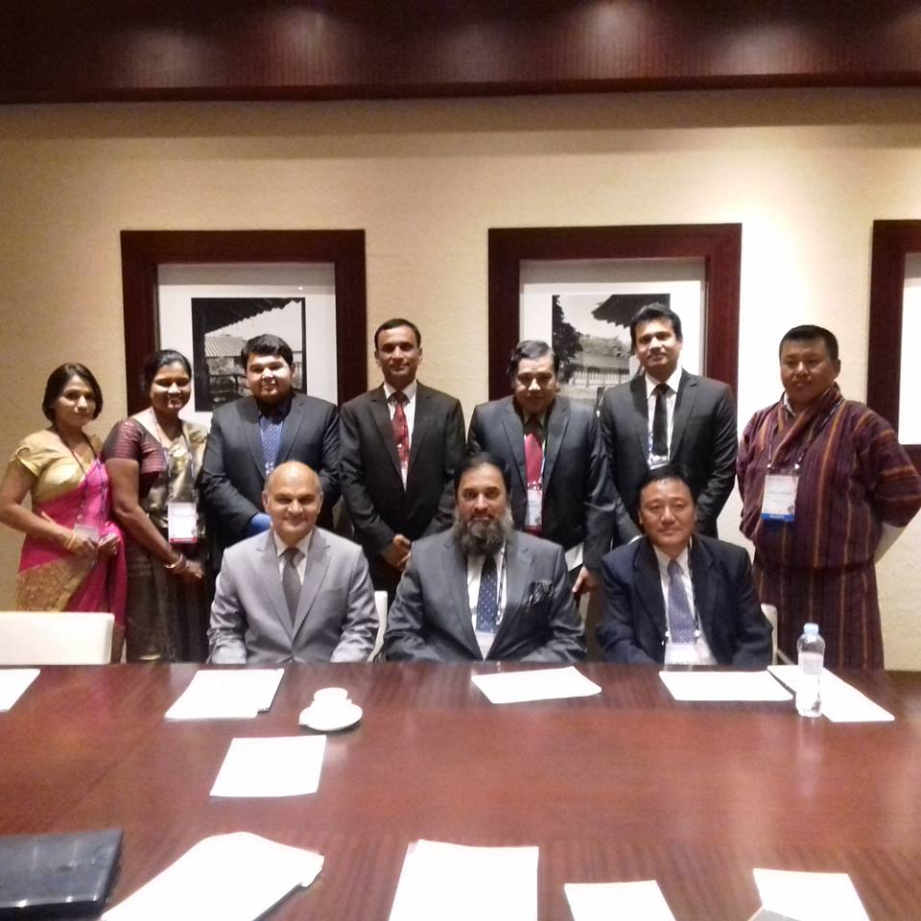

Day 2: Friday 12th May
In the morning a study visit has arranged to Changdeok Girls Middle School which is the only government funded future school in Seoul. At the entrance there is a digital wall and LEGO wall representing modern and old world. The classroom capacity is 12-15 students and students enjoy specialized curriculum. Some subjects combined together to provide more skills and experience to students.
In the afternoon there were 2 plenary sessions. In session 1-A is on Using OER to Achieve SDG4 which is chaired by Mr. Jongwon Seo, Chief, KERIS. There were three lectures. Flipped learning using K-MOOC By Mr. Jinhyuk Im, Professor, Pohang University of Science and Technology which described how to use Massive Open Online Courses (MOOC) in Education. Practices of teaching and learning using OER by Ms. Hyejung Im, Teacher, Seoul Gangdong Elementary School which showed the real experience with a teacher who use Open Education Resources. OER and Global Citizenship Education by Ms. Milee Ahn, Professor, Hanyang University discussed how OER and MOOC support 21st century learnings environment.
The theme of session 1B is Education Innovation for the Fourth Industrial Revolution which was chaired by Ms. Sungho Kwon, Emeritus Professor, Hanyang University. Diffusion of Education expertise in the 4th Industrial Revolution by Mr. SoonShik Suh, Professor, Chuncheon National University of Education was described 4th industry revolution and changes to Education. Software Education and Future Skills in the Fourth Industrial Revolution by Mr. Hyeoncheol Kim, Professor, Korea University discussed expected competencies by K-12 Education in future.

Session 2 is on the theme of Minimizing Risks without Restricting Opportunity: How Policy Can Support Digital Citizenship Education and Cyber wellness facilitated by Ms. Jonghwi Park, UNESCO Bangkok.
The 2 days forum helps to share knowledge and experience among the sub regional and regional member states, Strengthen the partnership within the region, get experience on the status of using ICT for Education is Republic of Korea which definitely useful in the future endeavors of ICT in Education back in Sri Lanka.

Mrs. M.A.Vasana Surangi Edirisuriya- Deputy Director of Education
Mrs. D.K.S.S.Dhanayake -Assistant Director of Education
ICT Branch
Ministry of Education
“ Isurupaya”
Battarmulla.

